**COVER PAGE**

**ADIDAS PROJECT REPORT**

(Project Semester January-May 2024)

***Earthquakes recorded from 1900-2013***

Submitted by

Polu Charan Teja

Registration No. 12112505

Programme and Section: B.Tech CSE and K21BS

Course Code: INTB233

Under the Guidance of

Nidhi Arora

**Assistant Professor**

**Discipline of CSE/IT**

**Lovely School of Computer Science and Engineering**

**Lovely Professional University, Phagwara**



**CERTIFICATE**

This is to certify that polu charanteja bearing Registration no. 12112505 has completed INTB233 project titled, **“Earthquakes recorded from 1900 to 2013”** under my guidance and supervision. To the best of my knowledge, the present work is the result of his/her original development, effort and study.

Nidhi arora

**Assistant Professor**

**School of Computer Science and Engineering**

Lovely Professional University

Phagwara, Punjab.

Date: 19-04-2024

**DECLARATION**

I, Atiketi Harshith, student of CSE under CSE/IT Discipline at, Lovely Professional University, Punjab, hereby declare that all the information furnished in this project report is based on my own intensive work and is genuine.

Signature: charan

Date: 18-04-2024

Registration No. 12112505

Name of Student: Polu Charan Teja

**Acknowledgment**

The satisfaction that accompanies the successful completion of this project would be in complete without the mention of the people who made it possible, without whose constant guidance and encouragement would have made efforts go in vain. I consider myself privileged to express gratitude and respect towards all those who guided us through the completion of this project.

I convey thanks to my project guide Baljinder Kaur of the Computer Science and Engineering Department for providing encouragement, constant support, and guidance which was of great help in completing this project successfully.

Last but not least, we wish to thank our parents for financing our studies in this college as well as for constantly encouraging us to learn engineering. Their personal sacrifice in providing this opportunity to learn engineering is gratefully acknowledged.

**1. Introduction**

Introducing the Earthquake Dashboard meticulously crafted using the powerful analytical tool, Tableau. This dynamic visualization offers a comprehensive exploration of seismic activity recorded from 1900 to 2013. Leveraging Tableau's intuitive interface and robust data visualization capabilities, this dashboard provides analysts with a user-friendly platform to delve into the intricacies of seismic events, unraveling the story behind the numbers. From geographical distribution and magnitude analysis to temporal trends between the pivotal years of 1900 and 2013, every facet of earthquake data is brought to life through interactive charts, maps, and insightful visualizations. Tableau's dynamic features enable users to drill down into the data, uncovering actionable insights and identifying patterns that could inform disaster preparedness strategies, infrastructure planning, and risk assessment.

Moreover, Tableau's versatility allows for seamless integration with external data sources, enabling stakeholders to augment seismic data with geological surveys, population density maps, and infrastructure vulnerability assessments for a holistic view of earthquake risk. With the ability to customize views, filter data, and generate on-the-fly visualizations, Tableau empowers users to tailor their analysis to specific research objectives and audience preferences, fostering collaboration and driving evidence-based decision-making in seismic hazard mitigation efforts.

In essence, the Earthquake Dashboard powered by Tableau transcends traditional reporting paradigms, offering a dynamic and interactive platform for exploring, analyzing, and deriving insights from seismic data. Whether you're a seismologist studying earthquake patterns, an emergency response coordinator planning disaster preparedness measures, or a policymaker shaping resilience strategies, this Tableau-powered dashboard serves as your indispensable companion in navigating the complexities of seismic risk and enhancing community resilience to earthquakes.

**2. Scope of Analysis:**

The scope of analysis for the Earthquake Dashboard created using Tableau offers a comprehensive exploration of seismic activity spanning from 1900 to 2013. Firstly, the dashboard delves into the geographical distribution of earthquakes by identifying regions with the highest frequency and intensity of seismic events, providing insights into seismic hazard zones and risk assessment. Secondly, it analyzes the magnitude and depth of earthquakes over time, facilitating the identification of trends, patterns, and potential correlations with geological features or tectonic plate boundaries. Thirdly, the dashboard tracks the temporal distribution of earthquakes throughout the year, enabling stakeholders to discern seasonal variations and potential triggers for seismic activity. Additionally, it highlights notable earthquakes based on their magnitude and impact, providing context for historical seismic events and lessons for disaster preparedness and mitigation efforts. Lastly, the analysis includes an examination of earthquake clusters and aftershock patterns, offering insights into the dynamics of seismic sequences and potential cascading effects on infrastructure and communities. Through this comprehensive scope of analysis, stakeholders gain a nuanced understanding of seismic risk and vulnerability, empowering them to make informed decisions and develop effective strategies for earthquake resilience and disaster management..

**3. Drawbacks or limitations of the existing system**

The existing system for analyzing seismic data through the Earthquake Dashboard, while leveraging Tableau's visualization capabilities, faces several notable limitations that impact its overall effectiveness and utility. One significant drawback is its reliance on manual data processing methods, which are susceptible to errors and can introduce inaccuracies into the analysis. Additionally, the system's scalability may be limited, particularly when dealing with large datasets or adapting to the evolving complexities of seismic activity patterns over time. Furthermore, if the system primarily offers static reports or pre-defined visualizations, it may hinder users' ability to conduct dynamic and nuanced analyses, restricting their capacity to uncover actionable insights and respond promptly to seismic events.

Moreover, the existence of data silos and integration challenges may impede the system's ability to access and integrate information from diverse sources, resulting in fragmented insights and hindering a comprehensive understanding of seismic risk. Additionally, while Tableau offers robust visualization tools, if the existing system lacks interactivity or user-friendly features, it may not fully capitalize on Tableau's potential to engage stakeholders and facilitate data-driven decision-making. Without intuitive interfaces and interactive functionalities, users may struggle to explore the data thoroughly and extract meaningful insights to inform disaster preparedness and mitigation efforts.

Addressing these limitations is crucial for optimizing the Earthquake Dashboard and maximizing its value in seismic analysis. By implementing automated data processing solutions, enhancing scalability to handle larger datasets, and promoting seamless integration with external sources, the system can overcome current constraints and unlock its full analytical potential. Furthermore, prioritizing interactive visualization features and user-friendly interfaces within Tableau can empower stakeholders to explore seismic data dynamically, derive actionable insights, and drive informed decision-making processes that enhance resilience to earthquakes and improve disaster response strategies.

**4. Source of DataSet:**

The dataset used for the Earthquake Dashboard is sourced from GitHub, a platform known for hosting diverse datasets contributed by users and organizations worldwide. This particular dataset focuses on seismic events recorded from 1900 to 2013 and includes essential data fields such as time, date, year, latitude, longitude, depth, magnitude, magnitude type, and more.

To access datasets like this on GitHub, users typically navigate to the repository containing the dataset, where they can download the data files for analysis. The dataset's availability on GitHub underscores the collaborative nature of data sharing and analysis in the scientific community.

Analyzing earthquake data serves various purposes, including understanding seismic trends, assessing risk, and informing disaster preparedness efforts. Researchers, seismologists, and policymakers can utilize such datasets to study patterns, identify seismic hotspots, and develop strategies for mitigating earthquake risks.

The dataset's inclusion of critical parameters such as location coordinates, magnitude, and depth enables researchers to conduct in-depth analyses and derive insights into seismic activity patterns over time. By leveraging this dataset, stakeholders can enhance their understanding of earthquake dynamics and contribute to efforts aimed at improving resilience to seismic events globally.

Top of Form

Here are the details of my chosen data set.

* Name: Earthquakes recorded from 1900-2013
* Link: https://github.com/DataScienceRoadMapDSRM/Tableau-Dashboards-info/blob/main/Mag6PlusEarthquakes_1900-2013.xlsx
* Format: xlsx
* No. of data sets: 1
* Number of Rows: 8314
* Number of columns: 17
* Size: 952 KB
* Date Fields:
  1. Time
  2. Date
  3. Time
  4. Latitude
  5. Longitude
  6. depth
  7. mag
  8. magtype
  9. nst
  10. gap
  11. dmin
  12. rms
  13. net
  14. id
  15. updated time
  16. place

**5. ETL process**

the ETL process facilitated the extraction, transformation, and loading of the earthquake dataset into Tableau, where it was utilized to create an informative and visually engaging dashboard for analyzing seismic activity recorded between 1900 and 2013.

**6. Analysis of DataSet**

6.1. Earthquakes recorded from 1900 to 2013

1. Introduction: This section offers a visual depiction of the geographical distribution of earthquakes recorded across various regions worldwide between 1900 and 2013. By examining seismic data at a global scale, analysts can uncover patterns, hotspots, and trends in seismic activity, aiding in understanding geological dynamics and seismic risk assessment. Through interactive maps, users can easily identify regions with higher seismicity levels, explore tectonic plate boundaries, and discern potential areas prone to earthquakes. Additionally, analyzing seismic events spatially allows stakeholders to prioritize disaster preparedness efforts, allocate resources effectively, and implement mitigation strategies tailored to specific regions' seismic characteristics.
2. General Description: Within the "Global Seismic Activity" section of the earthquake analysis dashboard, stakeholders are provided with an in-depth overview of seismic occurrences worldwide between 1900 and 2013. By visualizing earthquake data on a global scale, stakeholders gain insights into the distribution and intensity of seismic events across different continents and tectonic regions. This analysis enables them to identify seismic hotspots, fault lines, and regions with heightened seismic activity, facilitating informed decision-making in disaster preparedness, infrastructure planning, and risk mitigation efforts. With this comprehensive understanding of global seismic trends, stakeholders can develop targeted strategies to enhance resilience and minimize the impact of earthquakes on communities and infrastructure worldwide.
3. Analysis Result: Utilizing a map visualization, the seismic analysis highlights the geographic distribution of earthquakes recorded between 1900 and 2013. This map visually represents regions where seismic events have occurred, allowing stakeholders to identify areas with higher seismic activity levels and potential earthquake hotspots. By analyzing seismic data spatially, stakeholders can discern patterns in earthquake occurrence, such as clustering along fault lines or near tectonic plate boundaries. This spatial analysis aids in understanding the geological context of seismic events and enables stakeholders to prioritize resources for disaster preparedness and response efforts. Additionally, the map visualization serves as a valuable tool for educating the public, policymakers, and researchers about seismic risk and promoting proactive measures to enhance earthquake resilience globally.
4. Visualization:

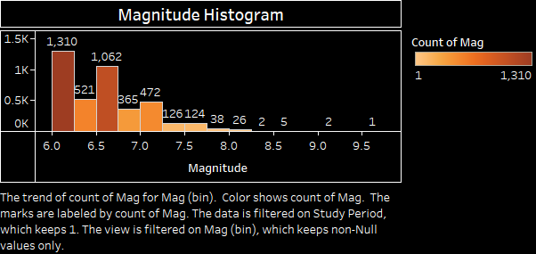

7.

Dashboard Picture:

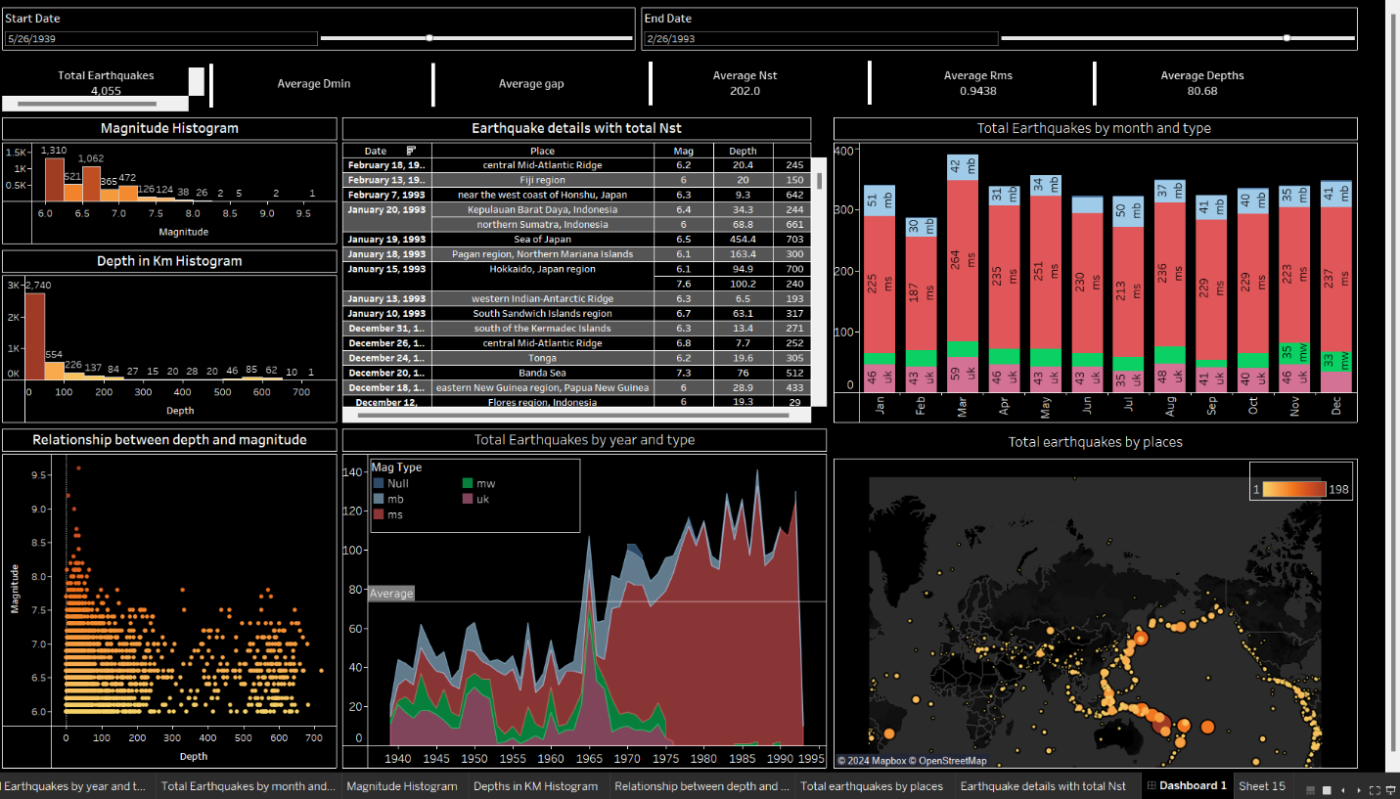

**8. Future Scope**

Looking ahead, there's a wealth of opportunities to expand and enhance the Adidas sales dashboard, leveraging Tableau's robust capabilities to deliver even greater insights and value. Firstly, incorporating predictive analytics could empower stakeholders to forecast future sales trends based on historical data, market dynamics, and external factors such as economic indicators and consumer sentiment. By integrating machine learning algorithms, the dashboard could dynamically predict sales volumes, identify emerging market trends, and recommend targeted strategies to capitalize on opportunities and mitigate risks.

Moreover, expanding the geographical scope beyond the USA could provide a broader perspective on Adidas's global sales performance, enabling stakeholders to compare regional trends, assess market saturation, and identify untapped markets for expansion. By integrating external data sources such as demographic information, social media trends, and competitor analysis, the dashboard could offer a comprehensive view of the competitive landscape and consumer preferences, empowering stakeholders to refine their marketing strategies, product offerings, and distribution channels effectively.

Furthermore, incorporating real-time data feeds could enable stakeholders to monitor sales performance and market trends in real-time, facilitating agile decision-making and rapid response to changing market conditions. By integrating Tableau with other analytics tools and platforms, such as customer relationship management systems and supply chain management software, the dashboard could offer end-to-end visibility into the sales process, from customer acquisition to product delivery, enabling stakeholders to optimize operations and enhance customer satisfaction.

Additionally, enhancing the interactivity and user experience of the dashboard could further engage stakeholders and facilitate deeper exploration of the data. By incorporating drill-down capabilities, filters, and dynamic visualizations, users could interactively explore sales data, uncover insights and answer ad hoc questions with ease. Moreover, incorporating storytelling features could enable stakeholders to communicate key findings and actionable insights effectively, fostering collaboration and driving alignment across the organization.

In summary, the future scope for the Adidas sales dashboard is vast and exciting, encompassing predictive analytics, global expansion, real-time monitoring, and enhanced interactivity. By leveraging Tableau's powerful capabilities and integrating diverse data sources, the dashboard can evolve into a strategic tool that empowers stakeholders to make informed decisions, drive business growth, and stay ahead in the dynamic and competitive landscape of the sportswear industry.